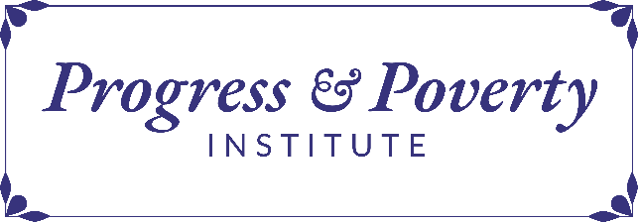
2026
Progress of Ideas Grant Application
Mason Gaffney Digital Collection
Background and Scope of RFP
In 2025, Progress and Poverty Institute partnered with the Danica Foundation and Mason and Letitia Gaffney Trust to create the first and only comprehensive digital and physical collection of the works of the late economist Mason Gaffney. The Mason Gaffney Digital Collection makes these works available, free of charge, in perpetuity, and consists of research, writings, working papers and notes, presentations, teaching materials, correspondence and items of a personal nature.
Progress and Poverty Institute invites proposals utilizing this collection. We welcome proposals in support of work to be disseminated in either traditional academic venues (e.g., journal papers) or popular ones (e.g., podcasts).
Eligibility Criteria:
- Applicants must be U.S.-based nonprofit organizations classified as 501(c)(3) organizations by the Internal Revenue Service.
- Grants of up to $10,000 will be considered.
- Research timelines of up to two years will be considered.
- No more than 10% of a grant may go to indirect costs.
- Grants will not be made for capital or endowment programs, sectarian religious purposes, lobbying, or other partisan purposes.
Application Instructions:
- Complete and submit the application, upload the budget template and a copy of your CV by the April 6, 2026 deadline.
- Grantees will be notified by May 12, 2026.
Artificial Intelligence Use Statement:
We recognize that applicants may use tools such as AI to help brainstorm ideas, clarify language, or assist with translation. These tools can support the application process, especially for non-native English speakers or those seeking to improve clarity. However, all submitted content must ultimately reflect your own original work, ideas, and voice. The use of AI or translation tools should be limited to supportive functions - not to generate full responses or replace your personal input. Applications that appear to be heavily or entirely AI-generated, or that do not demonstrate authentic, individual engagement with the application questions, may be subject to further review. Our application will ask whether and how you used AI tools.
Deliverables:
- Upon completion of the funded research, grant recipient(s) will participate in a one hour interview on Zoom, which will be recorded and shared as part of the PPI’s video catalog.
- Upon completion of funded research, grant recipients will participate in the creation of 2-3 YouTube shorts summarizing the research process.
- Upon completion of the funded research, grant recipient(s) will provide an 800-1500 word essay, suitable for publication on the PPI website and promotion on social media, summarizing their research question(s), methodology/ies, and findings and recommendations/next steps.
If you have any questions, or you have difficulties with the form, please email grants@progressandpovertyinstitute.org

